FBLA Adviser Handbook
2018-19

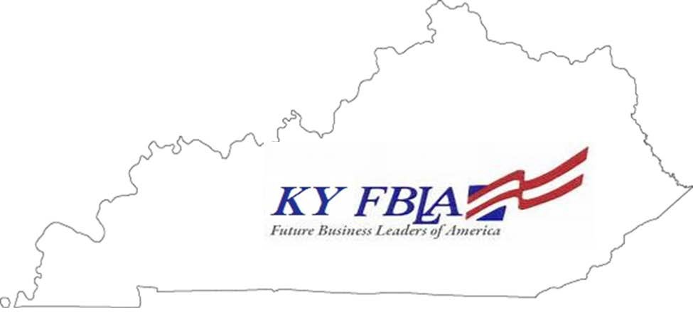

KY FBLA is
Your Ticket to Success

Adviser Handbook Index
Contact Information
State Adviser 1
Adviser to State Officers 1
FBLA Board of Directors 1
FBLA State Officers & Advisers 1
Kentucky FBLA Website Information 2
National FBLA Website Information 2
Chapter Management Handbook 2
Suggested Timeline 3
Membership Registration Step-by-Step Guide
Log-In Screen 7
School Information 8
Adviser Information 8
Selecting Members from a Prior Year 9
Adding New Members (First Time Joining) 9
Adding Professional Division Members 10
Payment Information 10
Statement Page 10
Competitive Events
Event Descriptions 11
Preparation 12
Competitive Event Changes/Modifications 2018-19 15
Competitive Event Topics 2018 16
Choosing an Event 21
Events at a Glance 23
Events by Career Cluster 25
Conferences
Regional 27
State Leadership Conference 27
National Leadership Conference 28
Registration and Submissions 28
Conference Attendance 28
Stipends to Competitors & Outstanding Adviser 29
Schedule of Conferences 30
Regional and State Officers
Candidate Information 31
Chapter Assistance from Officers 31
Traveling With Students
Conferences 32
Overnight Trips 32
Camp 32
Adviser-Only Area
Registration and Login 33
Chapter Management Handbook 34
Other Information
2018-19 Theme, Project, and Goals 35
Regional Map 36
Counties by Region 37

FBLA Adviser Handbook 2018-2019

Important Contact Information:

Connie Witt, KY FBLA State Adviser Debbie Barnett, Adviser to State Officers 300 Sower Boulevard, 5th Floor SW Debbie.barnett8@gmail.com
Frankfort, KY 40601
502-564-4286 ext. 4256

FBLA Board of Directors:

Region 1 Representative: Greta Ramage Livingston-Central High School
Region 2 Representative: Sheena Searcy Franklin-Simpson High School Region 3 Representative: Belinda Hodges Bardstown High School
Region 4 Representative: Shane Stamper Dixie Heights High School Region 5 Representative: Cheryl Wellman Greenup County ATC
Region 6 Representative: James Murray Pulaski County High School

FBLA State Officers and Advisers

President | Katlyn Barnes | Franklin-Simpson HS | Sheena Searcy
Vice President | Beau Mobley | Pulaski Co HS | James Murray
Secretary | Phoebe Clark | Larry A. Ryle HS | Brenda Klaas**
Treasurer | Hannah Bell | Crittenden Co HS | Amy Hardin
Reporter | Jimmy Poe | Bracken Co HS | Tracy Florer
Historian | Savannah Gifford | Paul G. Blazer HS | Ramona Bellew
Parliamentarian | Rebecca Jones | Hart Co HS | Deanna Vance
Region 1 President | Sarah Throgmorton | Graves Co HS | Stephanie Rickman**
Region 2 President | Katie Bunch | Franklin-Simpson HS | Sheena Searcy**
Region 3 President | Thomas Lay | Eastern HS | Todd Eastridge**
Region 4 President | Vacant
Region 5 President | Zach Linville | Nicholas Co HS | Kim Simons**
Region 6 President | JonBlake Richardson | Pulaski Co HS | James Murray**

**Regional Chairs (Contact information is available at kyfbla.org)

Kentucky FBLA Website (kyfbla.org) is your source of information for:

- State Theme, Goals and Project (Under Program of Work)
- State Executive Council Information
- Board of Directors Information
- Updated Kentucky FBLA By-Laws
- 2018-19 Calendar of Events
- Kentucky Competitive Events Guide (Available by August 1)
- Kentucky Dress Code
- Forms and Documents
⇒ Adviser Update Form
⇒ Unite to Serve Information
⇒ Promotional Items
⇒ Regional and State Officer Candidate Documents
⇒ State Newsletters
⇒ Financial Remittance Form
⇒ State Scholarship Donation Form
⇒ Medical Release Form
- State Approved Fundraiser List
- Regional Executive Councils

FBLA National Website (fbla-pbl.org)

- Local Chapter Membership Registration is completed through the National FBLA site. Log in with your chapter number (available from State Adviser) and password (Service)
- All national conference information is found here. Adviser-Only Area is for Advisers Only! Each local chapter adviser must create a unique username and password. (Lesson plans, Chapter Awards & Recognitions, Member Awards & Recognitions, National Projects, National Chapter Management Handbook, Nationals Calendar, plus many ideas and activities)
- Facts about FBLA
- Competitive Events Study Materials
- Professional Division Member Information
- FBLA Marketplace (Where you can order FBLA competitive events study materials, awards for your students, gifts, attire, etc.)

Chapter Management Handbook – Updates will arrive via mail from the national office. Replace these pages in your handbook. Contact the national office if replacement is needed.

July:
Suggested Timeline and Activities

- Attend the CTE Conference
- Complete and return the Adviser Update Form
- Email your local chapter president’s name and email to connie.witt@education.ky.gov
- Join as a Professional Division Member through FBLA-PBL.org
- Begin back-to-school preparations/promotional activities for your chapter
- Have officers finalize your Program of Work for the year

August:
- Watch for and READ emails from your Regional Chair and State Adviser. Respond when requested.
- Membership Recruitment Activities.
- Begin Collecting Dues - $4 for State and $6 for Nationals. All members are registered on National website and paid to FBLA-PBL by check, PO or credit card.
- Set aside time to enter members on the National site. Maybe weekly or bi-weekly.
- Begin advertising NFLC in New Orleans, LA, November 17-18, 2017.
- Plan Travel arrangements for NFLC.
- Advertise Regional Fall Leadership Conferences.
- Plan and hold chapter meetings.
- Meet with other CTSOs in your school to plan the Unite to Serve project. Resource Guide and Participation Form available at kyfbla.org.
- Carry out Program of Work.
- Plan fundraising for the year.
- Register students for National Programs (Business Achievement Awards (BAA), Community Service Awards (CSA), etc. at fbla-pbl.org.
- Review National Projects, Awards, and Recognitions. Decide and plan for those your chapter would like to participate in, such as Outstanding Chapter, Gold Seal Award of Merit, etc. available at fbla-pbl.org. Information/suggestions will also come from your State Adviser.
- Recruit Professional Division Members. These may be any teachers, administrators, business people, parents, former FBLA members, etc. (Top chapters will receive awards at the State Leadership Conference (SLC)
- Begin planning for activities to earn the Commonwealth Award of Merit at SLC.
- Plan for the Local Leadership Challenges, FBLA LLC. Money will be awarded at the regional and state levels to the top chapters.

Print the Kentucky Competitive Events Guide after updates. (Kentucky Awards Program, KAP) An email will notify you when it is available.

September:
  - Read and respond to emails from Regional Chair and State Adviser.
  - Regional Fall Conference registrations due. Information will come from your Regional President or Regional Chair.
  - Continue local chapter recruitment.

  - Continue collecting dues and posting members to the National FBLA site.
  - Continue carrying out local chapter Program of Work.
  - Continue NFLC planning. If you do a payment plan for students, collect money as scheduled.
  - Conduct Team Building activities at chapter meetings.
  - Consider some type of social activity.
  - Possible fundraising.
  - Make hotel reservations for NFLC.
  - Register students for NFLC before early-bird deadline of October 17.
  - Begin discussions with students about Competitive Events for Regional Spring Conferences.
  - Submit articles and pictures for Reporters’ Quill, Regional Newsletters and State Newsletters.

October:
  - Read and respond to emails from Regional Chair and State Adviser
  - Continue collecting dues and posting members to the National FBLA site.
  - Mail first set of dues BY October 10 to insure posting by October 20.
  - Register students for NFLC if not already done.
  - Continue carrying out local chapter Program of Work.
  - Conduct Team Building activities at chapter meetings.
  - Continue discussions and sign-ups with students about Competitive Events for Regional Spring Conferences. Some pre-judged events can begin preparations.
  - Submit articles and pictures for Reporters’ Quill, Regional Newsletters and State Newsletters
  - Fundraising
  - Community Service
  - Social Activities

November:
  - Read and respond to emails from Regional Chair and State Adviser.
  - Continue collecting dues and posting members to the National FBLA site.
  - Collect all Medical Release Forms and Code of Conduct Forms from NFLC attendees.
  - American Enterprise Day, November 15.
  - NFLC in New Orleans, LA, November 17-18.
  - Submit articles and pictures for Reporters’ Quill, Regional Newsletters and State Newsletters.
  - Continue signing students up for competitive events.

December:
  - Read and respond to emails from Regional Chair and State Adviser.
  - Watch for Regional Conference Memo with ALL necessary information—registration instructions, due dates, mailing addresses and submission instructions for Production forms and pre-judged events.

  - Double check Kentucky’s Competitive Events Guides as students prepare for competition.
  - Continue collecting dues and posting members to the National FBLA site.
  - Submit articles and pictures for Reporters’ Quill, Regional Newsletters and State Newsletters
  - Fundraising
  - Community Service
  - Chapter Meetings
  - Social Activities
  - Information should be available for Student Organization Leadership Day (SOLD) in Frankfort to be held on February 13, 2018. Watch for the registration deadline.

January:
  - Read and respond to emails from Regional Chair and State Adviser.
  - Continue collecting dues and posting members to the National FBLA site.
  - Production Forms are due to State Adviser by January 10, 2018, via email. The tests will be mailed to schools the week of January 15, 2018.

SUBMIT ALL DUES PAYMENTS IN TIME TO BE POSTED BY FEBRUARY 1.
  - Remember, the dues MUST SHOW as paid or the student(s) will NOT be permitted to attend a Regional Conference.
  - Complete the Kentucky Adviser Spotlight Form. See kyfbla.org for the form.
  - Take note of the February 1 deadline for all conference materials. Detailed information is in your conference memo from your Regional President.
  - Donate to the State Scholarship Fund. The form is available at kyfbla.org.
  - Register your Regional Conference Attendees online following the instructions from your Regional Chair.
  - Begin planning for National FBLA Week.
  - Submit articles and pictures for Reporters’ Quill, Regional Newsletters and State Newsletters

February:
  - Read and respond to emails from Regional Chair and State Adviser.
  - February 1 is the deadline for many things:
⇒ Spring Conference Registration will lock at midnight for all Regions
⇒ All dues must be posted in time to register students by midnight
⇒ All pre-judged and production events must be submitted by midnight
⇒ Regional Officer Applications must be postmarked to your Regional Chair
⇒ Plan activities for National FBLA Week, February 4-10, 2018. Feb. 6 – National Presidents’ Forum & FBLA Fight to the Finish
  - Submit articles and pictures for Reporters’ Quill, Regional Newsletters and State Newsletters

March:
  - Read and respond to emails from Regional Chair and State Adviser.
  - Attend your Regional Spring Conference. See conference schedule at kyfbla.org.
  - Check deadlines for State Conference registration, submission dates, hotel registration, Commonwealth Award of Merit, Submission of State Goals & Project, State and National Officer Applications, revised projects and Production tests.
  - All BAA and CSA submissions due by March 1.
  - Unite to Serve Evaluation due by March 1.

April:
  - Read and respond to emails from Regional Chair and State Adviser.
  - April 16-18, 2018 - State Leadership Conference.
  - May 7, 2018 - Final confirmation of National competitors due via email to State Adviser.
  - May 7, 2018 - Form C for FBLA NLC Conference due to State Adviser.
  - April 1 Due Date National recognitions.
  - Discuss FBLA Camp with your students. Final date TBD.
  - Begin planning for National Leadership Conference expenses and travel arrangements.

May:
  - Read and respond to emails from Regional Chair and State Adviser.
  - Revised Events, Projects and Production tests due. Date will come via email from State Adviser.
  - Mid-May is Early-Bird deadline for FBLA NLC in Baltimore, MD.
  - Reserve hotel rooms for NLC.
  - FBLA Camp Registration Due. Watch for exact date via email.

June:
  - Read and respond to emails from Regional Chair and State Adviser.
  - Be sure National competitors are practicing for their speaking events, interviews, and presentations as well as studying for online events.
  - NLC in Baltimore, MD, June 29-July 2, 2018.

July:
  - FBLA Camp

Member Registration Step-by-Step Guide fbla-pbl.org
STEP 1: SCHOOL INFORMATION

Both State and National dues are included in the check or credit card payment to the FBLA National office ($10 per student, $4 State and $6 Nationals.) Students must show as a paid member on the National site in order to travel with FBLA. The first set of dues must be paid by October 20 in order to receive communication from the National office. However, dues may be sent as early and as often as necessary. All students must show as paid on the National site by February 1 in order to compete or attend a regional conference. However, registration locks at midnight, so it is not advisable to wait until February 1 to pay by credit card unless it is done EARLY in the day.

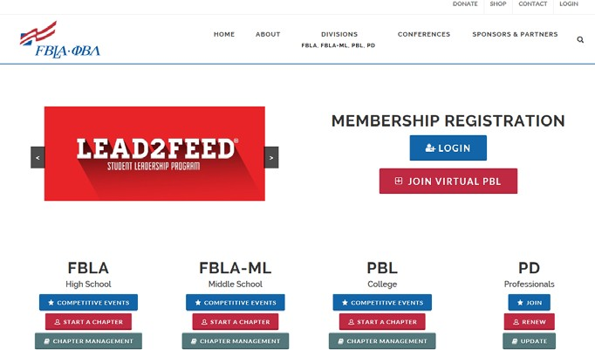
Click Login from the list home screen.

Enter chapter number (contact State Adviser if you don’t know it) and enter the password (Service).
Login.

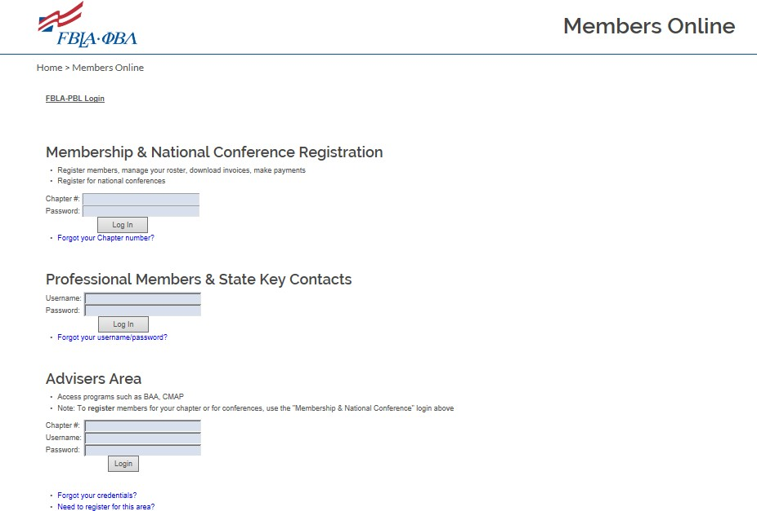
Click Here

Click “Edit School Information” to update adviser or school info.

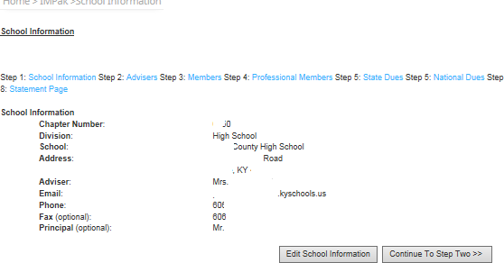

STEP 2: ADVISER INFO

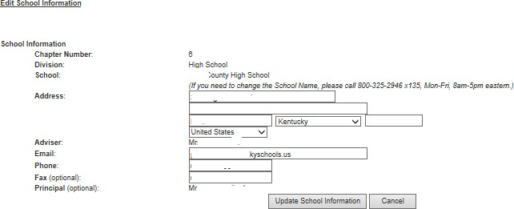
Edit info as needed. Click Here.

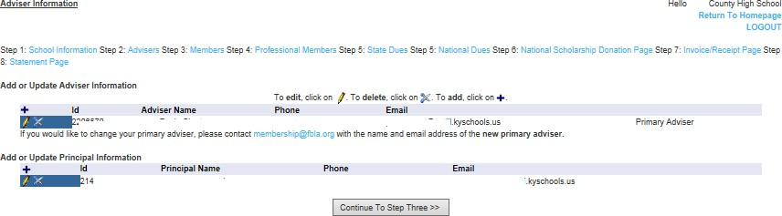
Click + to add adviser

Edit Adviser and Principal info as needed. Choose one adviser to be Primary Adviser.

Continue to Step 3 to add prior-year members.

STEP 3: MEMBERS

A list of prior-year members will show. Select those you are renewing. Be sure to update grade level before moving on from this page.
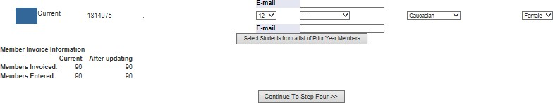

Click on + to add new members who have never joined in high school.
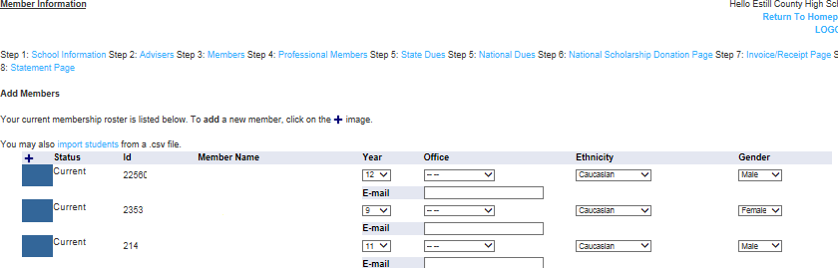

A page will come up to enter student information. Carefully enter the names and grade levels. Whatever you enter will be how the students appear on a drop-down menu to register for all conferences (NFLC, Regional, State and NLC).
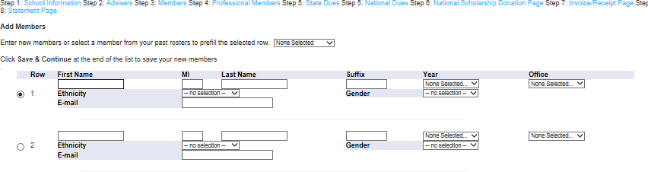

Do NOT use nicknames. Be sure to get first and last names in correct box. This is NOT a good thing to allow students to do.

STEP 4: PROFESSIONAL DIVISION MEMBERS
All chapters are encouraged to recruit professional division members, especially advisers, other teachers, administrators, business people, parents and former FBLA members.
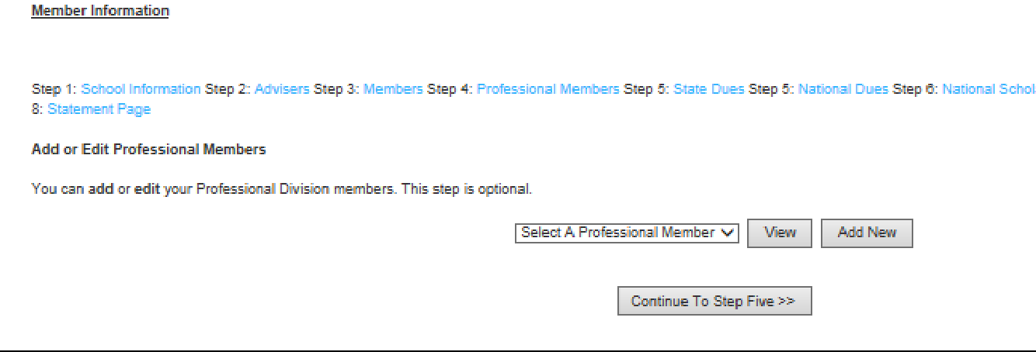

STEPS 5 AND 6: SHOW HOW MUCH IS OWED FOR STATE AND NATIONAL DUES BASED ON MEMBERS ENTERED.
STEP 7: NATIONAL SCHOLARSHIP FUND
Money donated here does NOT count toward the Kentucky Scholarship Donation. Please use the Kentucky form to donate.
STEP 8: STATEMENT PAGE
Print this page and mail with check to the address listed. The total includes both National and State dues.

COMPETITIVE EVENTS

Regional, state and national competition is an integral component of FBLA. Each competitive event is directly tied to at least one educational standard. Students are able to advance from one level to the next in the following manner:
- Compete in an individual or team event, as well as chapter events at the regional level.
- The top 3 in each event advance to the State Leadership Conference at the Galt House Hotel in Louisville, KY. Exceptions are Eugene H. Smith Scholarship (winner and runner- up only), Ethel M. Plock Scholarship (winner and runner-up only) and Talent Show (1st place only in each category.)
- Four competitors/teams in each event (excluding State Only events) are eligible to compete at the National Leadership Conference. Qualifying individuals/teams will be determined by the Board of Directors.

Event Descriptions:
- Individual – Only 1 member from each chapter may participate.
- Team – Only Parliamentary Performance is Team Only. Must be a team of 4-5.
- Individual or Team – Up to 3 members may participate.
- Individual Online Objective Test – This is an online test taken at the regional leadership conferences by the 1 member registered in this event. Up to one hour may be taken. In the event of a tie, the member completing the test first places higher. The computer times the test. For State competition, the online test is administered to the top 3 at the home school. Someone other than the adviser or business teacher must serve as test proctor. A testing window will be provided from the State Adviser.
- Team Online Objective Test – A team of 2 or 3 members gather around 1 computer and collaboratively take the test for Regional Competition. Teams will test separately and scores averaged for State Competition.
- Chapter Events – Up to 5 members from a chapter may participate in creating/developing chapter events. Members may also participate in an individual or team event as well.
- Production (Skills) Events – These events involve a production component that is completed at the home school in Computer Applications, Database Design & Applications, Spreadsheet Applications and Word Processing. Advisers must submit a Request Form included with the Regional Conference Memo to the State Adviser by January 10, 2018. It is not necessary to know which student will test at this time. Someone from the home school must be designated to administer this test. No adviser or business teacher is to serve in this role, offer assistance or be in the room during testing. Students advancing to state competition will complete an online object test during the testing window as well as a new production component.
- Pre-Judged Events: These are projects, reports, etc. completed and submitted by February 1 according to conference memo directions. Some events require a performance at regional and/or state competition as well. Some pre-judged events allow for participation in an additional event. Refer to the Kentucky Competitive Events Guide for specific information.

- Regional and State Only Events: These do NOT advance beyond the state level.
- State and National Only Events: These events are first submitted as directed in the State Leadership Conference memo that will be electronically distributed in February.

The Kentucky Competitive Events Guide will be distributed electronically. It will also be available at kyfbla.org.

Be sure to use the Kentucky FBLA Competitive Events Guide and State Theme for all regional and state competitions. Those advancing to the national level must check national guidelines and adapt to those.

Competitive Event Preparation

Many resources are available to assist students in competitive event preparation, both free and for purchase. The Kentucky Competitive Events Guide should be made available to students in preparation for competition. The guidelines and objectives can be found for each event.
Also, rating sheets used for judging are included. These should be followed when preparing reports, projects and presentations.

Study material, winning reports and projects and performance DVDs are available from the Marketplace (fbla-pbl.org). The FBLA Marketplace can be accessed from the National FBLA homepage. There are also websites and YouTube videos available in helping students prepare for competition. Free resources are available through the National site as well.
Screenshots and directions follow.

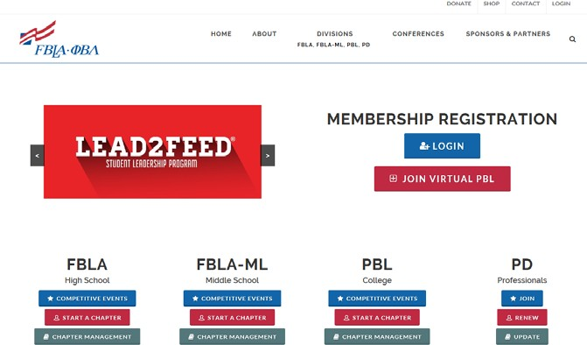
FBLA Marketplace (For Purchase) Select “Shop” and you will be directed to the Marketplace.

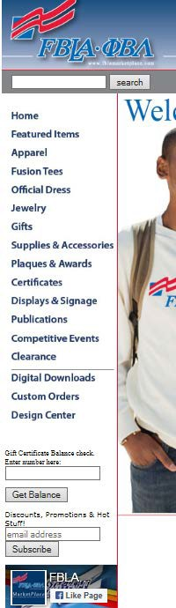
Not only are materials available for competitive event preparation, materials and supplies for your local chapter, official attire, awards and certificates, etc. are available as well.

Items may be purchased using a Purchase Order or a credit card.

MBA Research is another resource in competitive event preparation. A crosswalk has been developed and is available to teachers aligning all FBLA events with the national standards. Each event is linked to materials available through this site. Kentucky teachers have access to a number of free materials for use in both the classroom and event preparation.

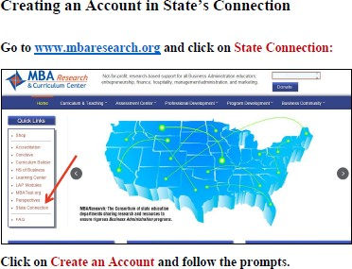
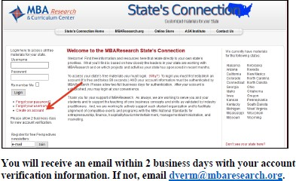

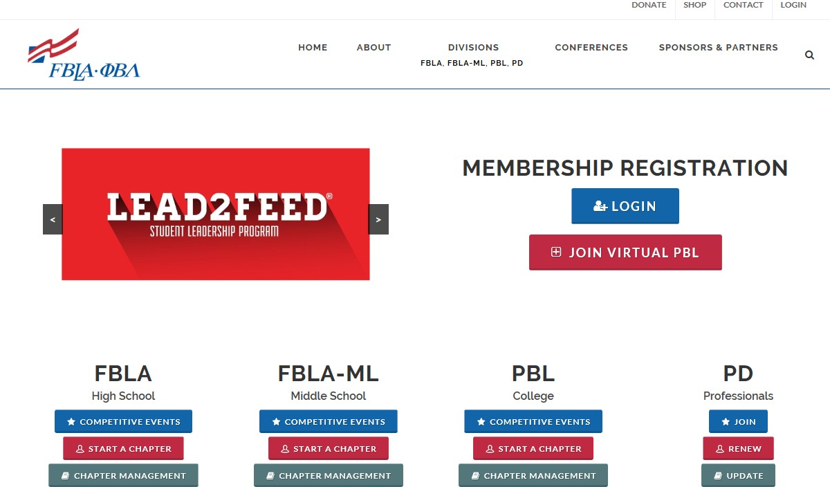
Free Resources (fbla-pbl.org)

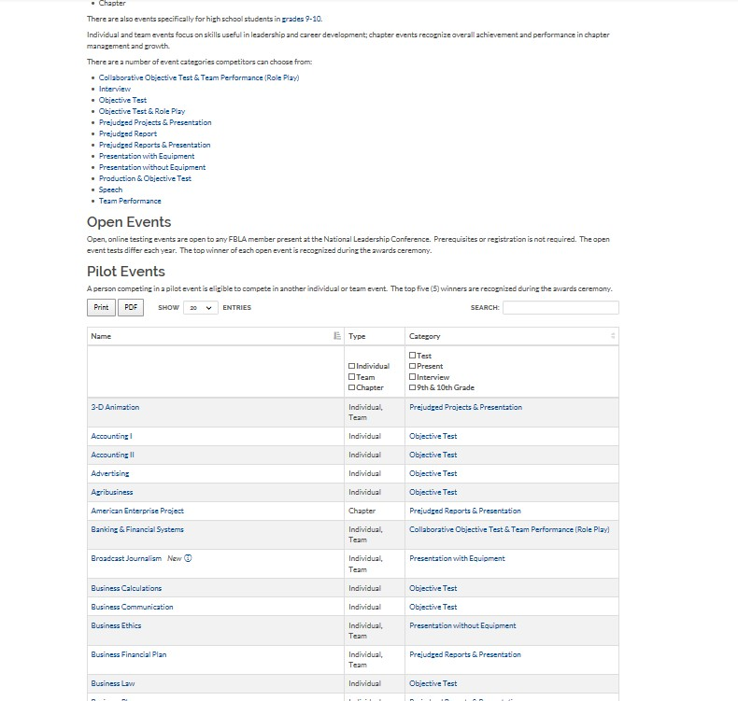
On the National FBLA Home Page, click Competitive Events under FBLA

Next, select the event study materials are needed for. If practice materials and/or videos are available for the selected event, those will be listed on the next screen.

Competitive Events Changes for 2018-19 from the Nat’l Office
FBLA:
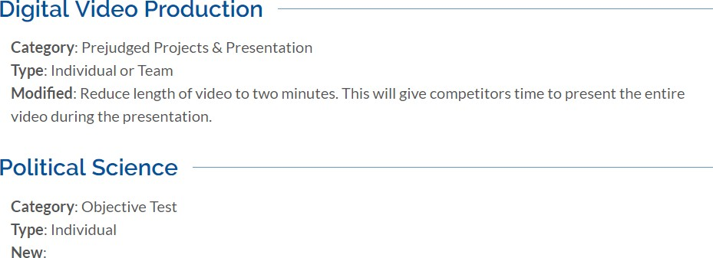

Modifications to the KY Competitive Events Guide

The following events will now have a performance component for the top eight (8) finalists at the State Leadership Conference:

3D Animation Digital Video Production

American Enterprise Project E-Business

Business Plan Mobile Application Development

Business Financial Plan Partnership with Business

Community Service Project Website Design

Computer Game & Simulation Programming

Finalists will be announced as quickly as possible, but all participants in these events should come to the SLC prepared to present.

Future Business Leader (FBL):
Seniors may now compete in FBL plus one other performance event at both the
regional and state conference. Interview times will be scheduled around other
performance times. This remains a senior-only event.

Talent Show:
There will be no designation between Most Talented and Most Entertaining. The
event will now be “Talent” with chapters permitted to have two entries in this event.

Coding and Programming:
More information will be forthcoming regarding this event.

2018-19 FBLA COMPETITIVE EVENT TOPICS

3-D ANIMATION
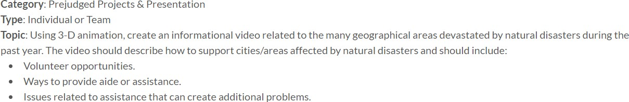

BROADCAST JOURNALISM
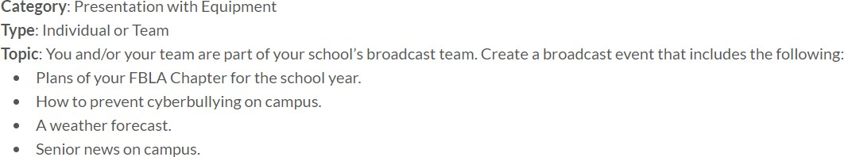

BUSINESS ETHICS

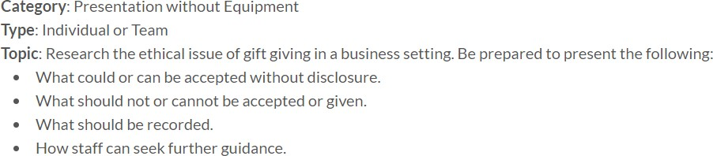

BUSINESS FINANCIAL PLAN
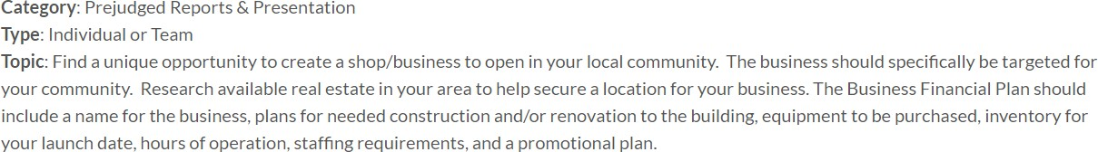
CODING AND PROGRAMMING
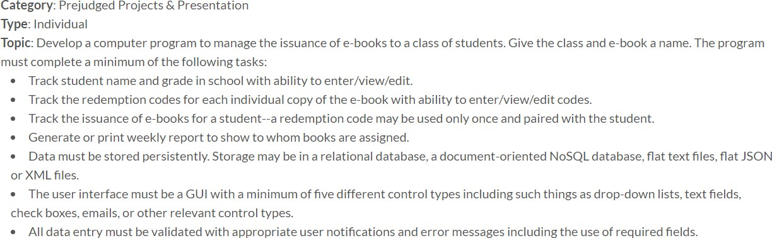

COMPUTER GAME & SIMULATION PROGRAMMING
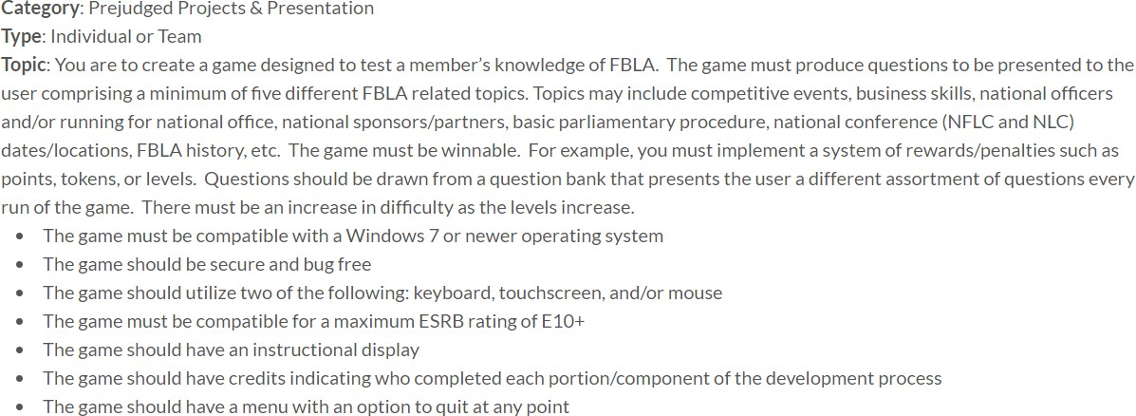

DIGITAL VIDEO PRODUCTION
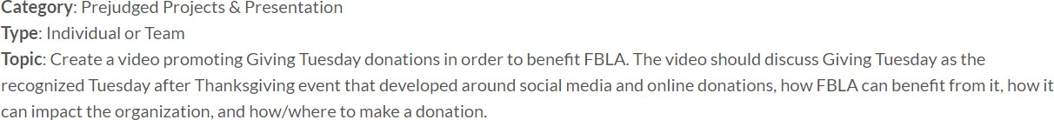

E-BUSINESS
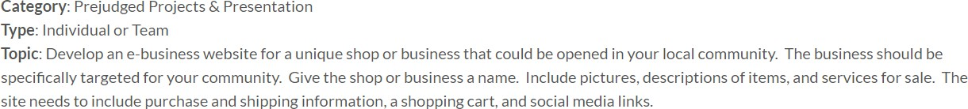

EMERGING BUSINESS ISSUES
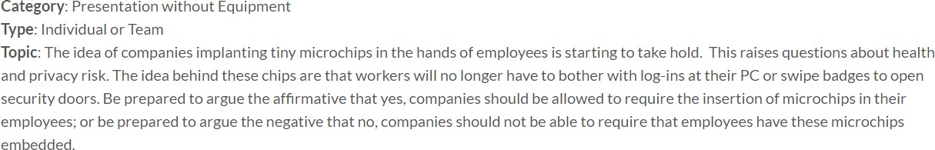

GRAPHIC DESIGN
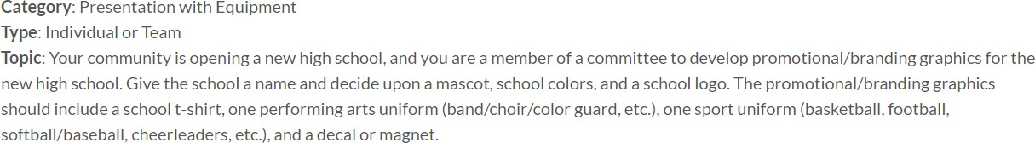

INTRODUCTION TO BUSINESS PRESENTATION
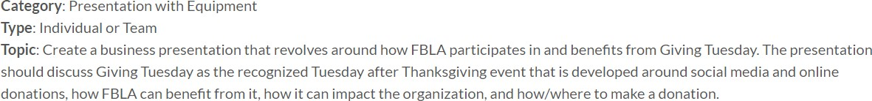

MOBILE APPLICATION DEVELOPMENT
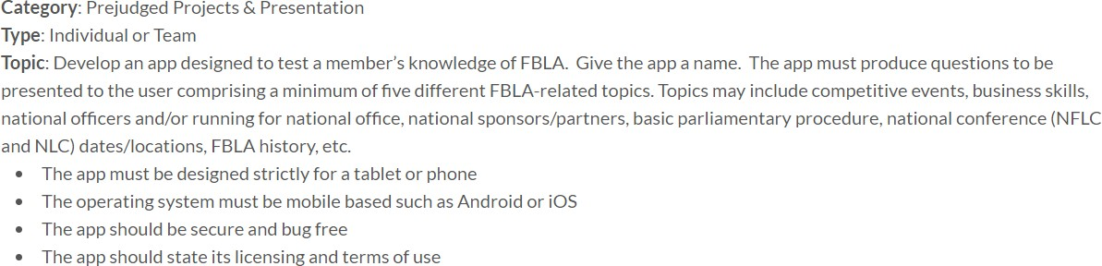

PUBLIC SERVICE ANNOUNCEMENT

PUBLICATION DESIGN
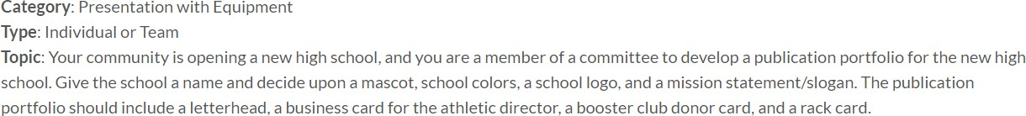

SOCIAL MEDIA CAMPAIGN
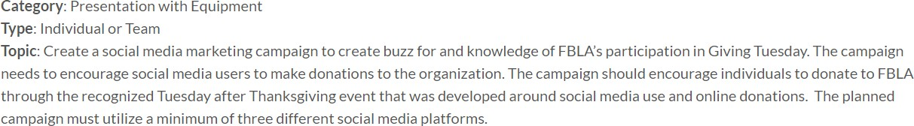

WEBSITE DESIGN
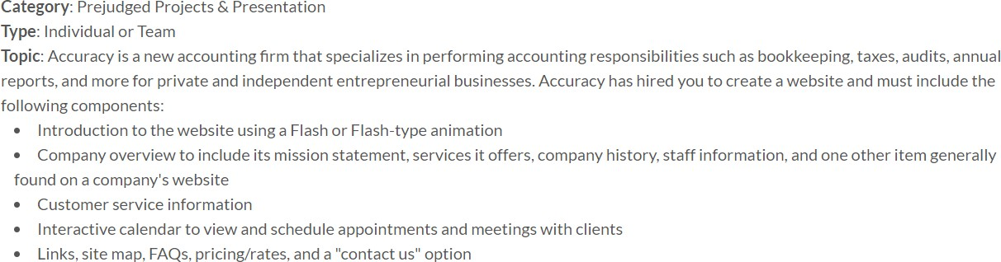

Choosing your FBLA competitive event

S AR
T
HERE

YES

Do you feel comfortable speaking in front of a small audience?

Would you like to
NO
Would you like to work on a project, presentation, or report that showcases your business or technical
knowledge?
work as part of NO

YES
a team?

YES
Events that require a project, presentation, or report developed on a given topic or competencies.
Chapter Events American Enterprise Project Community Service Project
Local Chapter Annual Business Report Partnership with Business Project

Individual Event
Coding & Programming

Individual or Team Events
3-D Animation Broadcast Journalism Business Ethics Business Financial Plan Business Plan
Computer Game & Simulation Programming Digital Video Production
E-business Emerging Business Issues
Graphic Design Mobile App Development
Public Service Announcement Publication Design
Social Media Campaign Website Design

YES

9th & 10th Grade Speaking or Presentation Event
Introduction to Business Presentation Introduction to Public Speaking
Are you in 9th or 10th grade?

NO

T

1 | FBLA-PBL.ORG
1 | FBLA-PBL.

Individual or team events requiring a role-play type performance covering a variety of topics and requiring an objective test.
Banking & Financial Systems Entrepreneurship Global Business
Hospitality Management Management Decision Making Management Information Systems Marketing
Network Design Parliamentary Procedure
Sports & Entertainment Management
Speaking Events
Impromptu Speaking Public Speaking
Interview Events
Future Business Leader (test also) Job Interview

Interactive Role Play Events
Client Service Help Desk (test also)
Presentation Events
Electronic Career Portfolio Sales Presentation

21

NO
LifeSmarts (2-member team) Virtual Business Finance Challenge
Virtual Business Management Challenge

Do you use one or more pieces of office application software
well (Microsoft Office—Word, Excel, PowerPoint, Access, etc.; OpenOffice—Writer, Calc,
Impress)?

NO
Objective test events open to any grade level covering a variety of topics.
Accounting I Accounting II Advertising Agribusiness Business Calculations
Business Communication Business Law
Computer Problem Solving Cyber Security Economics
Health Care Admininistration Insurance & Risk Management Journalism
Networking Concepts Organizational Leadership Personal Finance Securities and Investments

Are you in 9th or 10th

YES
grade? NO

YES
Try
Computer Applications Database Design & Applications Spreadsheet Applications
Word Processing

For more information, visit fbla-pbl.org/FBLA/ competitive-events/
9th & 10th Grade Objective Test Events
Introduction to FBLA Introduction to Business
Introduction to Business Communication Introduction to Business Procedures Introduction to Financial Math Introduction to Information Technology Introduction to Parliamentary Procedure

22
C

FBLA EVENTS AT-A-GLANCE

FBLA Competitive Events | # of State Entries | Event Type | Objective Test Time | Collaborative Objective Test | Prejudged Report/Project | Home-site Production Test/ Time | National Preliminary Round | National Final Round | Equipment Setup Time | Prep. Time | Performance Time | Q&A | Interactive Role Play
3-D Animation | 4 | I, T |  |  | x |  | x | x | 5 |  | 7 | 3
Accounting I | 4 | I | 60
Accounting II | 4 | I | 60
Advertising | 4 | I | 60
Agribusiness | 4 | I | 60
American Enterprise Project | 4 | C |  |  | x |  | x | x | 5 |  | 7 | 3
Banking & Financial Systems | 4 | I, T | 60 | x |  |  |  | x |  | 20 | 7 |  | x
Broadcast Journalism | 4 | I, T |  |  |  |  | x | x |  |  | 7 | 3
Business Calculations | 4 | I | 60
Business Communication | 4 | I | 60
Business Ethics | 4 | I, T |  |  |  |  | x | x |  |  | 7 | 3
Business Financial Plan | 4 | I, T |  |  | x |  | x | x | 5 |  | 7 | 3
Business Law | 4 | I | 60
Business Plan | 4 | I, T |  |  | x |  | x | x | 5 |  | 7 | 3
Client Service | 4 | I |  |  |  |  | x | x |  | 10 | 5 |  | x
Coding & Programming | 4 | I |  |  | x |  | x | x | 5 |  | 7 | 3
Community Service Project | 4 | C |  |  | x |  | x | x | 5 |  | 7 | 3
Computer Applications | 4 | I | 60 |  |  | 2 hrs
Computer Game & Simulation Programming | 4 | I, T |  |  | x |  | x | x | 5 |  | 7 | 3
Computer Problem Solving | 4 | I | 60
Cyber Security | 4 | I | 60
Database Design & Applications | 4 | I | 60 |  |  | 1 hr
Digital Video Production | 4 | I, T |  |  | x |  | x | x | 5 |  | 7 | 3
E-business | 4 | I, T |  |  | x |  | x | x | 5 |  | 7 | 3
Economics | 4 | I | 60
Electronic Career Portfolio | 4 | I |  |  |  |  | x | x | 5 |  | 7 | 3
Emerging Business Issues | 4 | I, T |  |  |  |  | x | x |  |  | 7 | 3
Entrepreneurship | 4 | I, T | 60 | x |  |  |  | x |  | 20 | 7 |  | x
Future Business Leader | 4 | I | 60 |  | x |  | x | x |  |  | 10,15
Global Business | 4 | I, T | 60 | x |  |  |  | x |  | 20 | 7 |  | x
Graphic Design | 4 | I, T |  |  |  |  | x | x | 5 |  | 7 | 3
Health Care Administration | 4 | I | 60
Help Desk | 4 | I | 60 |  |  |  |  | x |  | 10 | 5 |  | x
Hospitality Management | 4 | I, T | 60 | x |  |  |  | x |  | 20 | 7 |  | x
Impromptu Speaking | 4 | I |  |  |  |  | x | x |  | 10 | 4
Insurance & Risk Management | 4 | I | 60
46 | FBLA-PBL.ORG 23

FBLA EVENTS AT-A-GLANCE

FBLA Competitive Events | # of State Entries | Event Type | Objective Test Time | Collaborative Objective Test | Prejudged Report/Project | Home-site Production Test/ Time | National Preliminary Round | National Final Round | Equipment Setup Time | Prep. Time | Performance Time | Q&A | Interactive Role Play
Introduction to Business (9th–10th grade) | 4 | I | 60
Introduction to Business Communication (9th–10th grade) | 4 | I | 60
Introduction to Business Presentation (9th–10th grade) | 4 | I, T |  |  |  |  | x | x | 5 |  | 7 | 3
Introduction to Business Procedures (9th–10th grade) | 4 | I | 60
Introduction to FBLA (9th–10th grade) | 4 | I | 60
Introduction to Financial Math (9th–10th grade) | 4 | I | 60
Introduction to Information Technology (9th–10th grade) | 4 | I | 60
Introduction to Parliamentary Procedure (9th–10th grade) | 4 | I | 60
Introduction to Public Speaking (9th–10th grade) | 4 | I |  |  |  |  | x | x |  |  | 4
Job Interview | 4 | I |  |  | x |  | x | x |  |  | 10,15
Journalism | 4 | I | 60
LifeSmarts | 2 | T | 30 | x |  |  | x | x
Local Chapter Annual Business Report | 4 | C |  |  | x
Management Decision Making | 4 | I, T | 60 | x |  |  |  | x |  | 20 | 7 |  | x
Management Information Systems | 4 | I, T | 60 | x |  |  |  | x |  | 20 | 7 |  | x
Marketing | 4 | I, T | 60 | x |  |  |  | x |  | 20 | 7 |  | x
Mobile Application Development | 4 | I, T |  |  | x |  | x | x | 5 |  | 7 | 3
Network Design | 4 | I, T | 60 | x |  |  |  | x |  | 20 | 7 |  | x
Networking Concepts | 4 | I | 60
Organizational Leadership | 4 | I | 60
Parliamentary Procedure | 4 | T | 60 |  |  |  |  | x |  | 20 | 9–11
Partnership with Business Project | 4 | C |  |  | x |  | x | x | 5 |  | 7 | 3
Personal Finance | 4 | I | 60
Public Service Announcement | 4 | I, T |  |  |  |  | x | x | 5 |  | 5 | 3
Public Speaking | 4 | I |  |  |  |  | x | x |  |  | 5
Publication Design | 4 | I, T |  |  |  |  | x | x | 5 |  | 7 | 3
Sales Presentation | 4 | I |  |  |  |  | x | x | 5 |  | 7 |  | x
Securities & Investments | 4 | I | 60
Social Media Campaign | 4 | I, T |  |  |  |  | x | x | 5 |  | 7 | 3
Sports & Entertainment Management | 4 | I, T | 60 | x |  |  |  | x |  | 20 | 7 |  | x
Spreadsheet Applications | 4 | I | 60 |  |  | 1 hr
Virtual Business Finance Challenge | 2 | I, T |  |  |  |  | x | x |  |  | 25
Virtual Business Management Challenge | 2 | I, T |  |  |  |  | x | x |  |  | 25
Website Design | 4 | I, T |  |  | x |  | x | x | 5 |  | 7 | 3
Word Processing | 4 | I | 60 |  |  | 1 hr

24

AGRICULTURE
Agribusiness Business Ethics
Electronic Career Portfolio Job Interview
Organizational Leadership
ARTS, A/V TECHNOLOGY, & COMMUNICATION
3-D Animation Broadcast Journalism Business Ethics
Coding & Programming
Computer Game & Simulation Programming Digital Video Production
Electronic Career Portfolio
Graphic Design Help Desk
Job Interview Journalism
Mobile Application Development Network Design
Networking Concepts
Organizational Leadership Public Service Announcement Publication Design
Social Media Campaign Website Design

BUSINESS MANAGEMENT & ADMINISTRATION

3-D Animation Accounting I Accounting II Advertising Agribusiness
American Enterprise Project Banking & Financial Systems Business Calculations Business Communication Business Ethics
Business Financial Plan Business Law
Business Plan Client Service
Coding & Programming Community Service Project Computer Applications
Computer Game & Simulation Programming Database Design & Applications
E-business
Economics
Electronic Career Portfolio Emerging Business Issues Entrepreneurship
Future Business Leader Global Business Graphic Design
Health Care Administration Help Desk
Hospitality Management Impromptu Speaking Insurance & Risk Management Introduction to Business
Introduction to Business Communication Introduction to Business Presentation Introduction to Business Procedures Introduction to FBLA
Introduction to Financial Math Introduction to Parliamentary Procedure Introduction to Public Speaking
Job Interview LifeSmarts
Local Chapter Annual Business Report Management Decision Making Management Information Systems Marketing
Organizational Leadership Parliamentary Procedure Partnership with Business Project Personal Finance
Public Speaking Publication Design
Sports & Entertainment Management Spreadsheet Applications
Virtual Business Management Challenge Word Processing

FBLA EVENTS BY CAREER CLUSTERS
FINANCE
Accounting I Accounting II
Banking & Financial Systems Business Calculations Business Ethics
Business Financial Plan Business Plan
E-business Economics
Electronic Career Portfolio Entrepreneurship
Future Business Leader Global Business
Health Care Administration Insurance & Risk Management Introduction to Business Introduction to Business Procedures Introduction to Financial Math
Job Interview LifeSmarts
Local Chapter Annual Business Report Management Decision Making Management Information Systems Organizational Leadership
Personal Finance Securities & Investments
Virtual Business Finance Challenge
GOVERNMENT & PUBLIC ADMINISTRATION
Accounting I Business Ethics
Accounting II Electronic Career Portfolio`
Banking & Financial Systems Global Business
Health Care Administration Job Interview Organizational Leadership

50 | FBLA-PBL.ORG 25

HUMAN SERVICES
Banking & Financial Systems Business Communication Business Ethics
Business Financial Plan Business Plan
Client Service
Electronic Career Portfolio
Entrepreneurship Future Business Leader Global Business
Health Care Administration Hospitality Management Help Desk
Impromptu Speaking
Introduction to Business Presentation Introduction to Business Procedures Job Interview
Management Decision Making Management Information Systems Organizational Leadership

INFORMATION TECHNOLOGY

American Enterprise Project Business Ethics
Client Service
Coding & Programming Community Service Project Computer Applications
Computer Game & Simulation Programming Computer Problem Solving
Cyber Security
Database Design & Applications Digital Video Production
E-business
Electronic Career Portfolio Emerging Business Issues
Future Business Leader Graphic Design
Health Care Administration Help Desk
Hospitality Management Introduction to Business Presentation Introduction to Business Procedures
Introduction to Information Technology Job Interview
LifeSmarts
Local Chapter Annual Business Report Management Information Systems Mobile Application Development Network Design
Networking Concepts Organizational Leadership Partnership with Business Project Publication Design
Social Media Campaign Spreadsheet Applications
Virtual Business Finance Challenge Virtual Business Management Challenge Website Design
Word Processing

FBLA EVENTS BY CAREER CLUSTERS
LAW & PUBLIC SAFETY
Business Ethics Business Law
Electronic Career Portfolio
Health Care Administration Job Interview
Management Decision Making
Management Information Systems Organizational Leadership
MARKETING, SALES, & SERVICE
Accounting I Accounting II Advertising Agribusiness
Business Communication Business Ethics
Business Plan Client Service
Coding & Programming Digital Video Production E-business
Economics
Electronic Career Portfolio
Entrepreneurship Future Business Leader Global Business Graphic Design
Hospitality Management Impromptu Speaking Insurance & Risk Management Introduction to Business
Introduction to Business Communication
Introduction to Public Speaking Job Interview
LifeSmarts
Local Chapter Annual Business Report
Management Decision Making Marketing
Organizational Leadership Partnership with Business Project Public Speaking
Publication Design Sales Presentation Social Media Campaign
Virtual Business Management Challenge Website Design
Word Processing
S.T.E.M.
3-D Animation Business Ethics
Coding & Programming Community Service Project Computer Applications
Computer Game & Simulation Programming
Computer Problem Solving Cyber Security
Database Design & Applications Digital Video Production Electronic Career Portfolio Graphic Design
Help Desk Job Interview
Organizational Leadership Publication Design
Social Media Campaign Website Design

26

REGIONAL, STATE AND NATIONAL CONFERENCES

Regional Conferences
Most regions host a fall conference. This is similar to FBLA Leadership Development Camp, with officer training, fundraising ideas, meeting ideas, etc. Each region does hold a spring conference. The spring conferences are where the competitive events are held and/or the top three in each event are recognized with a trophy. The top three (3) at the regional level, with the exception of Smith & Plock Scholarships (winner and alternate only) and Talent Show (first place in Most Entertaining and Most Talented) advance to the State Leadership Conference at the Galt House Hotel, Louisville, in April.
Information about registration for all regional conferences comes from the Regional President or the Regional Chair. Regional registration and submission instructions should be followed for all regional conferences. Also, the Kentucky Competitive Events Guide should be followed in submitting events.
Due to the quick turn-around time, potential competitors should have a good idea prior to the conference as to whether or not he/she will be able to attend the State Leadership Conference so that the 4th place competitor may be contacted in the event that a top three (3) finisher cannot attend the SLC. Teams may, however, substitute one (1) member between the regional and state conference.
Reports, projects and credentials may be edited between the regional and state conference as long as the conference deadlines are met. Students placing in the top three (3) in production events (Computer Applications, Database Design & Applications, Spreadsheet Applications, and Word Processing) will complete both a production component and an online objective test for the State Conference. The advisers of the top three (3) in each of these events needs to mail the test administrator’s name and email address for the production component to the State Adviser. Testing information will then be sent to the administrator.

KY FBLA piloted a minimum score requirement for advancement from the 2018 Regional Conferences to the 2018 State Leadership Conference. The Board of Directors will meet July, 2018 to decide as to whether this will be a permanent guideline.
State Leadership Conference
The top three (3) competitors in each regional event are qualified to compete at the state level. Registration and submission instructions will come from the State Adviser in early February.

The submission instructions will be different from the regional submission instructions.
Advisers with students advancing to the state level in an online objective test or a production (Skills) event should secure a test proctor for these events. Local chapter advisers or business teachers are not permitted to proctor these events. Paperwork will come from the state adviser requesting proctor information.

Each state may send up to four entries in each event; therefore, it is absolutely necessary for all students to talk with parents and all advisers to talk with administration prior to the State Leadership Conference about this possibility. As students exit the stage from
receiving awards, they should be prepared to give a “yes” or “no” to national competition. Those individuals/teams placing 1st and 2nd in objective test events with a performance component at state will advance to national competition. The 3rd and 4th place in these events will be made up of a Super Team determined by the State Adviser.

Conference Registration and Submissions
Regional conference registration and submission guidelines will be included in the Regional Conference Memo from each Regional President. These will be electronically distributed in early December.
State conference registration and submission guidelines will be included in the State Conference Memo from the State Adviser in early February. Submission guidelines will be different.
National conference registration and payment will be completed by the local chapter adviser, even if the adviser will not be attending the national conference with the student(s). Students will be entered in events by the State Adviser. Submission guidelines for reports, projects, and credentials will be available from the National office and sent out by the State Adviser.

Conference Attendance
A local chapter adviser must attend regional and state conferences with his/her students. However, students qualifying for national competition may attend under the supervision of another Kentucky adviser if the local chapter adviser is unable to attend. Parents may take their children, but an adviser must still be assigned with all paperwork completed prior to the conference (chaperone consent form, medical release form and signed code of conduct.)

National Leadership Conference
As money is available, each 1st place competitor, state officer, the Kentucky Who’s Who recipient, and the Kentucky Outstanding Adviser will receive a stipend toward national conference expenses. Because all states may take the four (4) in each event, it is imperative to know which students intend to go to Nationals in case he/she qualifies.
Advisers are responsible for registering all attendees from his/her local chapter (members, advisers, guests) for the conference as well as making hotel and travel arrangements.
Competitors will be registered for specific events by the state adviser.
If a student has committed to attend and compete but later is unable to do so, the state adviser should be contacted immediately in case there is still time to allow another competitor to take that spot.
It is not necessary for a local chapter adviser to accompany competitors to the national leadership conference if unable to do so. Notify the state adviser, and another Kentucky adviser will be assigned as the official chaperone to the student(s). A Chaperone Consent Form must be completed by both parties, initiated by the competitor’s adviser. Completed

forms should be sent to the state adviser. Completed Medical Release Forms and Code of Conduct Forms should be sent to the official adviser.

Stipends Awarded to KY National Competitors

All members receiving a stipend from KY FBLA will be required to complete and return a Good Faith Agreement. A portion or all of the stipend may be awarded prior to the conference.
Members and advisers must attend and furnish proof of attendance to certain required functions including, but not limited to, the KY meeting at NLC, Opening Session & Campaign Rally, the Southern Region Awards Session and Campaign Rally, the Southern Region Voting Assembly, and the Award of Excellence Program. Stipend recipients must also complete his/her entire event, preliminary round and final round. All of these events must be attended in their entirety. Failure to do so will result in remaining stipend not received, and/or a request for reimbursement of stipend.

KENTUCKY FUTURE BUSINESS LEADERS OF AMERICA 2018-19 CONFERENCE SCHEDULE

DATE | CONFERENCE | LOCATION
JUNE 28-JULY 1, 2018 | NATIONAL LEADERSHIP CONFERENCE | Baltimore, MD
October 18, 2018 | REGION 1 FALL LEADERSHIP CONFERENCE | MURRAY STATE UNIVERSITY MURRAY, KY
October 12, 2018 | REGION 2 LEADERSHIP CONFERENCE | WESTERN KENTUCKY UNIVERSITY BOWLING GREEEN, KY
October 18, 2018 | REGION 3 FALL LEADERSHIP CONFERCE | SPALDING UNIVERSITY LOUISVILLE, KY
October 16, 2018 | REGION 4 FALL LEADERSHIP CONFERENCE | NORTHERN KENTUCKY UNIVERSITY
October 11, 2018 | REGION 5 FALL LEADERSHIP CONFERENCE | MOREHEAD STATE UNIVERSITY  MOREHEAD, KY
October 25, 2018 | REGION 6 FALL LEADERSHIP CONFERENCE | EASTERN KENTUCKY UNIVERSITY  RICHMOND, KY
Nov 2-3, 2018 | NATIONAL FALL LEADERSHIP CONFERENCE | CHICAGO, IL
February 12, 2019 | CAREER AND TECHNICAL STUDENT ORGANIZATION DAY | FRANKFORT, KY
March 4, 2019 | REGION 1 LEADERSHIP CONFERENCE | MURRAY STATE UNIVERSITY MURRAY, KY
March 15, 2019 | REGION 2 LEADERSHIP CONFERENCE | WESTERN KENTUCKY UNIVERSITY BOWLING GREEN, KY
March 12, 2019 | REGION 3 LEADERSHIP CONFERENCE | SPALDING UNIVERSITY LOUISVILLE, KY
March 13, 2019 | REGION 4 LEADERSHIP CONFERENCE | NORTHERN KENTUCKY UNIVERSITY HIGHLAND HEIGHTS, KY
March 14, 2019 | REGION 5 LEADERSHIP CONFERENCE | MOREHEAD STATE UNIVERSITY MOREHEAD, KY
March 8, 2019 | REGION 6 LEADERSHIP CONFERENCE | EASTERN KENTUCKY UNIVERSITY RICHMOND, KY
APRIL 15-17, 2019 | STATE LEADERSHIP CONFERENCE | GALT HOUSE LOUISVILLE, KY
APRIL 20-22, 2020 | STATE LEADERSHIP CONFERENCE | GALT HOUSE LOUISVILLE, KY
JULY 17-19, 2018 | FBLA LEADERSHIP DEVELOPMENT CAMP | LAKE CUMBERLAND 4-H CAMP EDUCATIONAL CENTER, NANCY, KY
JUNE 29-JULY 2, 2019 | NATIONAL LEADERSHIP CONFERENCE | SAN ANTONIO, TX
JUNE 29-JULY 2, 2020 | NATIONAL LEADERSHIP CONFERENCE | SALT LAKE CITY, UT

REGIONAL AND STATE OFFICER CANDIDATES

Members are encouraged to run for regional and state office. Guidelines, qualifications and required attendances will be included with the regional conference memo from the regional president. State officer candidate guidelines, qualifications, and required attendances will be included with the state conference memo from the state adviser. All of the above information will also be available at kyfbla.org.

Several offices have required classes that the candidate must either have completed or be in the process of completing. Enrolling in the required class for the upcoming year does not meet the requirement.

Required attendance will be shared as they are available. Rarely will there be changes to these requirements; however, officers and advisers must arrange to be present at these required attendances.

Local Chapter Assistance

Regional and state officers and advisers are available to assist local chapters as needed. Contact your regional chair for more information. Contact your state adviser or adviser to state officers at any time as well.

MOST IMPORTANTLY, ASK QUESTIONS ANY TIME! We are all in this
together.

TRAVELING WITH STUDENTS

Traveling with students is one of the highlights of being an FBLA adviser. There are, however, some guidelines to keep in mind:

- Students must have paid dues AND show as paid on the National site to travel with or attend any FBLA function, conference or activity.
- A completed Medical Release Form must be with the adviser when traveling with members.
- A completed Code of Conduct must be present at any conference attendance.
- A local chapter adviser must attend regional, state and national fall conferences with his/her members. National competitors may attend under the supervision of another adviser.
- A completed Code of Conduct and Medical Release Form must be turned in for all members and advisers at FBLA Camp Registration. A chapter adviser must attend and room in a cabin with his/her members. Advisers with members of the opposite sex attending Camp will share the chaperoning duties with another chapter. EX—a female adviser will chaperone in her cabin the female students of a male adviser. The male adviser will then chaperone that female adviser’s male students in his cabin. All advisers are expected to room with his/her students. If for some reason this is not possible, another adviser from the school should accompany the students to camp. Students must be chaperoned at all times.
- For overnight trips, ensure all students are in their own rooms/cabins by curfew and stay put. Advisers should monitor hallways until certain this is so. At FBLA Camp, advisers shall stay in the common areas where students are until curfew unless all students are taken to the cabin with him/her.
- When chaperoning students in hotels, keep the following in mind:
⇒ Male and female students must never be in each others’ room unless an adviser is present.
⇒ Out of respect for other hotel guests, keep students quiet in hallways.
⇒ No loud music, dancing, games, etc. should take place in hallways.

Adviser-Only Area (fbla-pbl.org)

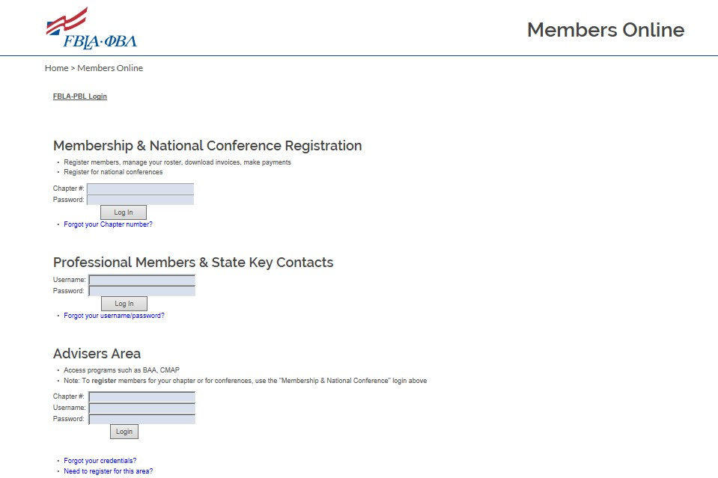
To access the Adviser Area, a username and password must first be created. This should not be the chapter number and “service” as the username and password. This login is unique to you and should not be shared with students.
Enter your chapter number. Contact State Adviser
he site password.
if unsure.

“Service” is t

This will be your unique login for the Adviser-Only Area.

To register one student.

To register multiple students.

1st, register as a 1st-time user.

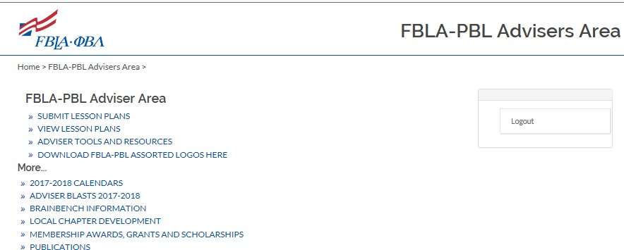

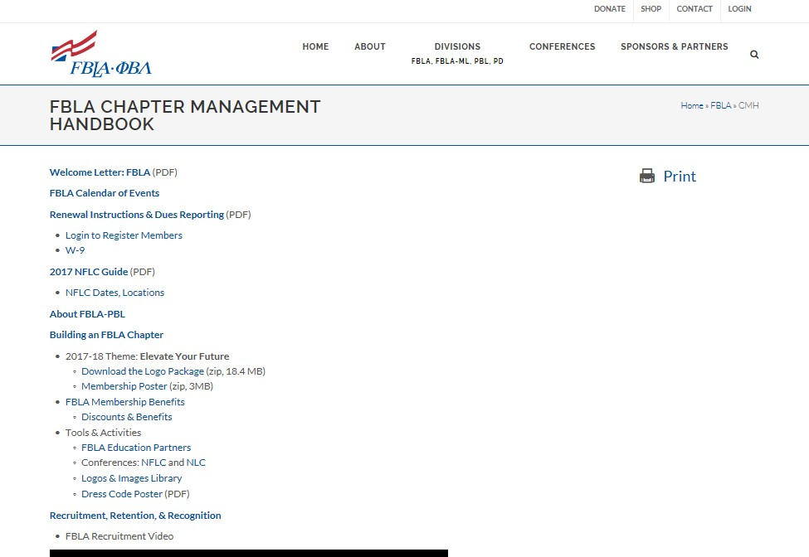

KENTUCKY FBLA
2018-19 State Theme, Project & Goals

2018-19 Kentucky FBLA State Theme
KY FBLA IS YOUR TICKET TO SUCCESS

2018-19 Kentucky FBLA State Project

Leading the Future Leaders
2018-19 Kentucky FBLA Goals

Goal 1: Increase or maintain chapter membership
Goal 2: Encourage member and chapter participation in FBLA programs
Goal 3: Participate in community service activities Goal 4: Enhance communication and visibility of FBLA
Goal 5: Increase the active pursuit of leadership through
candidacy for local, state, and/or national FBLA
offices.

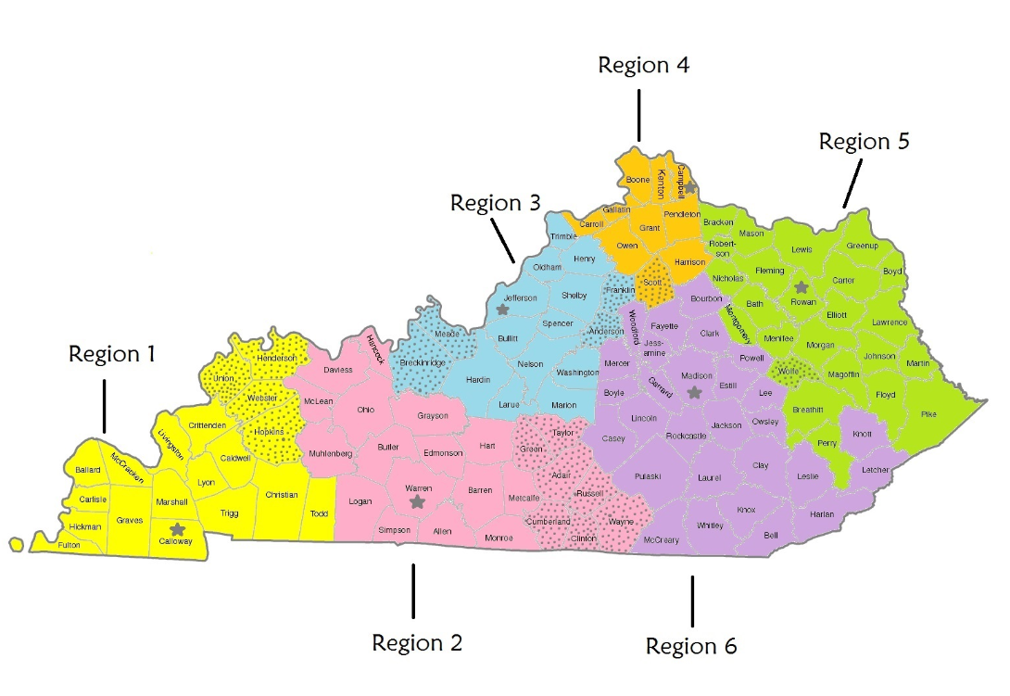

36

County List by FBLA Region
Region 1 | Region 2 | Region 3 | Region 4 | Region 5 | Region 6
Ballard | Adair | Anderson | Boone | Bath | Bell
Caldwell | Allen | Breckinridge | Campbell | Boyd | Bourbon
Calloway | Barren | Bullitt | Carroll | Bracken | Boyle
Carlisle | Butler | Franklin | Gallatin | Breathitt | Casey
Christian | Clinton | Hardin | Grant | Carter | Clark
Crittenden | Cumberland | Henry | Harrison | Elliott | Clay
Fulton | Daviess | Jefferson | Kenton | Fleming | Estill
Graves | Edmonson | Larue | Owen | Floyd | Fayette
Henderson | Grayson | Marion | Pendleton | Greenup | Garrard
Hickman | Green | Meade | Scott | Johnson | Harlan
Hopkins | Hancock | Nelson |  | Lawrence | Jackson
Livingston | Hart | Oldham |  | Lewis | Jessamine
Lyon | Logan | Shelby |  | Magoffin | Knott
Marshall | McLean | Spencer |  | Martin | Knox
McCracken | Metcafe | Trimble |  | Mason | Laurel
Todd | Monroe | Washington |  | Menifee | Lee
Trigg | Muhlenberg |  |  | Montgomery | Leslie
Union | Ohio |  |  | Nicholas | Letcher
Webster | Russell |  |  | Perry | Lincoln
 | Simpson |  |  | Pike | Madison
 | Taylor |  |  | Robertson | McCreary
 | Warren |  |  | Rowan | Mercer
 | Wayne |  |  | Wolfe | Owsley
 |  |  |  |  | Powell
 |  |  |  |  | Pulaski
 |  |  |  |  | Rockcastle
 |  |  |  |  | Whitley
 |  |  |  |  | Woodford

37

